Selection of Wind Turbine for Alma, Quebec: Eocycle EOX S-16
Case Study: Alma, Quebec
Location Overview
Alma is located in the Saguenay–Lac-Saint-Jean region of Quebec, Canada, with coordinates 48.55°N latitude and 71.65°W longitude. The region experiences a humid continental climate with warm summers and cold winters, making it suitable for both solar and wind energy generation. The average wind speed in Alma is between 4-5 m/s, which is ideal for small to mid-sized wind turbines.
Load Requirement and Application
For a residential or small commercial application in Alma, Quebec, the energy requirements are typically around 15-20 MWh annually. This makes the EOX S-16, with its annual energy production capability, a suitable candidate. The turbine will be used to provide renewable energy for a small business or residential complex, reducing dependency on grid power and lowering carbon emissions.
Wind Turbine Selection: Eocycle EOX S-16
Specifications
Rated Power: 20 kW to 30kW depending on version
Annual Energy Production: 40-70 MWh at wind speeds of 4-5 m/s
Cut-in Wind Speed: 2.75 m/s
Rated Wind Speed: 7.5 m/s (Average Annual Wind Speed)
Cut-out Wind Speed: 20 m/s
Rotor Diameter: 15.8 meters
Hub Height: 16.8 or 23.8
Blade Length: 7.6 m

Design Diagram
Below is a simplified design diagram of the Eocycle EOX S-16 wind turbine:
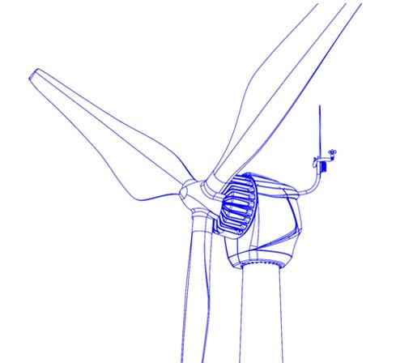
Detailed Discussion
Performance and Suitability
The Eocycle EOX S-16 is designed for moderate wind speeds, making it suitable for Alma, Quebec, where the average wind speed is 4-5 m/s. The turbine's ability to start generating power at low wind speeds (cut-in at 2.5 m/s) ensures consistent energy production throughout the year. The operating temperature of the turbine is -20ºC to 40ºC which makes it suitable for our application as the temperature varies for Alma, Quebec is between -20ºC to 25ºC.
Energy Production Analysis
Based on the site's average wind speed, the EOX S-16 is expected to produce between 40 and 70 MWh annually. This output is well above the required 17.78 MWh, ensuring that the energy needs are comfortably met and excess energy can be stored or sold back to the grid.
Load Matching
For a residential complex or small business in Alma, the EOX S-16 can provide a significant portion of the required energy, leading to reduced electricity bills and a lower carbon footprint. The consistent axial thrust and efficiency in handling variable wind conditions also ensure reliable operation and maintenance predictability. In EOX S-16, have a very few moving parts and also it has no gearbox so, it will reduce the periodic maintenance of the system. It has a good design life of 30 years without any major component replacement.

Economic and Environmental Impact
The installation of the EOX S-16 wind turbine will significantly cut down on electricity costs, providing a return on investment within a few years. Environmentally, it contributes to reducing greenhouse gas emissions, aligning with Quebec’s renewable energy goals.
Conclusion
The EOX S-16 wind turbine is an ideal choice for the given site in Alma, Quebec, based on its specifications, performance, and ability to meet the local energy requirements. Its robust design and efficiency in moderate wind conditions make it a reliable source of renewable energy. Detailed analysis and site-specific data support the feasibility and benefits of this installation, ensuring long-term sustainability and economic advantages.
For more such details, I had attached the specifications document at the end of this report.

